Lab 5: Composition
Objective:
The objective of this lab is to teach students how to implement composition relationship between classes using C++ code.
Learning Outcomes:
After this lab, the students can write C++ code for the composition relationships between classes.

Problem Statement

Consider the following UML class diagram having composition relationships between classes Customer and Account.

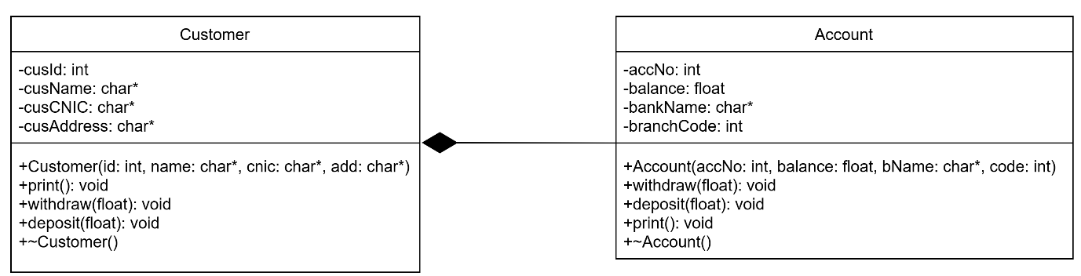

Customer class has the following data members:
- Customer id
- Customer name
- Customer CNIC
- Customer Address
- Account

The class should have the following member functions:
- Parameterized constructor
- print()
- withdraw()
- deposit()
- Destructor

Account class has the following data members:
- Account No.
- Balance
- Bank name
- Branch code

The class should have the following member functions:
- Parameterized constructor
- withdraw()
- deposit()
- print()
- Destructor

You are required to implement the composition relationship between classes using C++ code.

Within the main () function, create an object of Customer class and initialize its data members along with the Account details.
Now, call the deposit() function to deposit some amount then call the print () function which will display all the values of Customer including their ID, name, CNIC, address and account details.
Then, call the withdraw function to withdraw some amount and call the print () function which will display all the values of Customer including their ID, name, CNIC, address and account details.

Sample Output:

Following is a sample output for the above scenario:

